Relay Output 1W-UNI
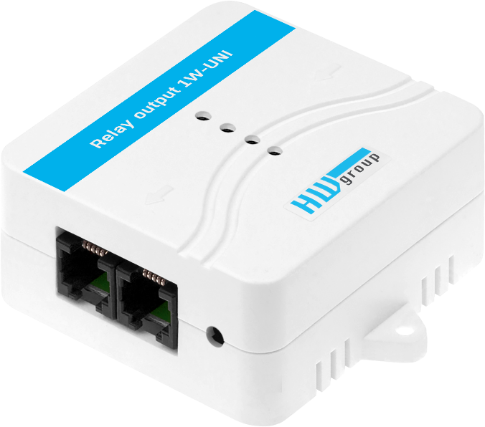
External Relay output 1W-UNI module allows to expand Ares 12 functionality by remote control of up to 4 relay outputs with a dry contact (NO/NC) capable of up to 50V / 1A load.

The relay outputs can be controlled via the SensDesk portal as well as through local conditions (alarms) in the Ares unit or via SMS.

The Relay output 1W-UNI module always uses 4 sensor positions from the 1-Wire UNI bus limit. When used with Ares 12 which can connect up to 14 external sensors next to the Relay Output 1W-UNI you can connect for instance up to 10 temperature sensors.

To one active port (RJ11 connector of the Ares device) maximum of 2 Relay output 1W-UNI can be connected. To strengthen the power supply an external 5V adapter or a powered “1-Wire hub Power” accessory can be used.

Supplied with a 3m RJ11 cable.

- Interface: 1-Wire UNI (2x RJ11)
- Connects to: Ares 12 (and Ares 14)
- Output: 4x relay output – NO/NC (50V / 1A total)
- Addresses: Each DO output has one unique sensor ID
- Limitations: The module uses 4 sensor positions of the 1-Wire UNI bus
- Power: Bus-powered (1-Wire UNI) or external 5V adaptor
- Environment: Indoor use

Keywords:
Relay Output 1W-UNI, Ares DO expansion, external DO ports, dry contact output, expansion module, controlling digital output, relay output, relay expander

