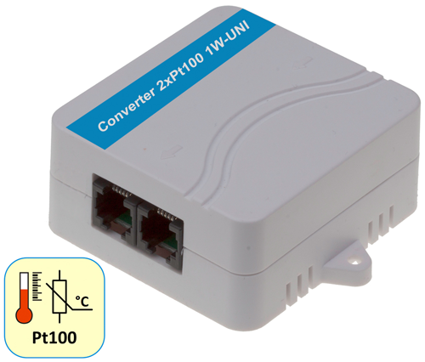
Converter 2xPt100 1W-UNI 2xPt100 1W-UNI
Converter to connect one or two external Pt-100 probes to the 1-Wire UNI bus.

The external 0-20mA input signal is electrically isolated from the output 1Wire-UNI bus. Pt100 or Pt1000 temperature sensors are detected automatically.

- Input: 2x Pt-100 or Pt-1000
- Probe connection: 2 or 3 or 4 wires
- Electrical isolation: No
- Options: Unit conversion, calibration.
- Interface: 1-Wire UNI (2x RJ11 for daisy-chaining)
- Connects to: Poseidon 2250, 4002, Ares 12/14, Poseidon2
- Power supply: Bus-powered (1-Wire UNI) – max. 2 sensors per active port.
- Environment: Indoor use

CZ Keywords:
Converter 2xPt100 1W-UNI, Pt100, Pt1000, pt100 čidlo teploty, externí pt100 čidlo, dva externí senzory pt-1000, pt100 na ethernet

pt100 převodník, pt100 teploměr, pt100 pt1000 autodetekce, měření teploty, převodník signálu, pt100 na snmp, pt-1000 na Modbus/tcp

EN Keywords:
Converter 2xPt100 1W-UNI, Pt100, Pt1000, pt100 temperature sensor, external pt100 probe, two external sensors pt1000, pt100 to ethernet

pt100 transmitter, pt100 thermometer, pt100 pt1000 auto-detection, measurement of temperature, signal converter, pt100 to snmp, pt-1000 to Modbus/tcp

pt100 temperature sensor 590
pt100 probe 210
sensor pt100 590
pt100 pt1000 110
sensor pt1000 110
pt 100 sensor 210
pt100 thermometer 110
pt100 transmitter 140
measurement of temperature 590

