Sensor 4-20mA 1W-UNI
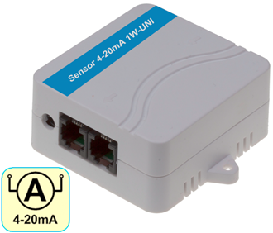
4-20mA current loop sensor converts a 4-20mA signal from an external probe to the 1-Wire UNI bus.

The sensor includes a current source for the external 4-20mA probe. The 4-20mA current loop input is electrically isolated from the output 1Wire-UNI bus.

- Input: 4-20mA (connect a “sink” type of probe).
- Electrical isolation: Yes
- Options: Unit conversion, calibration.
- Interface: 1-Wire UNI (2x RJ11 for daisy-chaining)
- Connects to: Poseidon 2250, 4002, Ares 12/14, Poseidon2
- Power supply: Requires an external 12-30V supply.
- Environment: Indoor use

CZ Keywords:
Sensor 4-20mA 1W-UNI, čidlo 4 až 20 mA, proudové čidlo, proudová smyčka, převodník signálu

Převodník proudu, měření proudu, měření tlaku, proudová smyčka 0 až 20 mA

EN Keywords:
Sensor 4-20mA 1W-UNI, 4 to 20 mA DC (sink), 4-20ma current loop, 4-20ma signal, 4-20ma converter, signal converter,

current transducers, ac current sensor, ac current measurement, current sensing, voltage transducer, dc current sensor, pressure transducers,

