HWg-WLD Relay: 2D Water Leak Detection with relay output
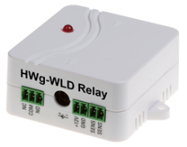
HWg-WLD Relay detects a water leak anywhere along the length of the connected sensing cable (up to 85m). Water leak or cable disconnection is indicated by activating a relay output (NO/NC). The sensor can be also connected to the Poseidon or Ares unit over the 1-Wire UNI bus (RJ11).

To detect water leaks or floods, HWg-WLD Relay uses the „WLD sensing cable A“ in lengths of 2m to 85m. There is a 2m sensing cable included in the standard delivery. Water or any other conductive liquid is detected along the entire length of the sensing cable. The sensing cable can be extended anywhere by a non-sensing prolong cable up to 185m in total.

The moisture-absorbing sensing cable detects even the smallest volume of water, ethylene glycol, or other conductive liquid. It can be dried and reused.

HWg-WLD Relay can be installed stand-alone using a 12VDC power supply and a relay output. Also can be used as a sensor connected to Ares or Poseidon unit over the 1-Wire UNI bus. Relay outputs indicate a detected water leak or cable disconnection.

- Sensor type: “WLD sensing cable A” Standard types: 2 / 10 / 50 meters
- Supplied sensor: 2 m water sensing cable + 2 m leader cable
- Detection zone: WLD sensing cable (max 85m) can be extended by non-sensing extension cable (max 100m).
- Leak detection: Water / glycol or other conductive liquid

- Relay output: NO/NC max. 1A / 30V (requires 12V power)
- Bus interface: 1-Wire UNI (2x RJ11) for Poseidon or Ares devices

- Power: 12V / 0.1A or over the 1-Wire bus
- Relay signaling: Relay activated when water detected or cable disconnected.
- 1-Wire UNI signaling: Not Flooded / Flooded / Cable disconnected

HWg-WLD relay, water sensing cable, water leak detector, water flood detector, water leak, relay water

Relay water detector, water leak detection, pipeline leak detection, liquid detection cable, water flood detector, cable based water leak detection, spot detector

WLD sensing cable A - 2+2m
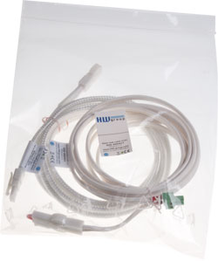
Water leak detection cable pack for ”HWg-WLD” and ”HWg-WLD Relay” products. Includes 2m connection cable and 2m detection cable (total length 4m) and terminator.

- Water Leak Detection cable: 2m (6.5ft)
- Connection leader cable: 2m (6.5ft)
- Extension: Up to 85m (280ft) total length, use “WLD sensing cable A”.
- Compatible with: HWg-WLD, HWg-WLD Relay

WLD sensing cable A – 2+10m
Water leak detection cable pack for ”HWg-WLD” and ”HWg-WLD Relay” products. Includes 2m connection cable and 12m detection cable (total length 12m) and terminator.
.

- Water Leak Detection cable: 10m (33ft)
- Connection leader cable: 2m (6.5ft)
- Extension: Up to 85m (280ft) total length, use “WLD sensing cable A”.
- Compatible with: HWg-WLD, HWg-WLD Relay

