Sensor 0-20mA 1W-UNI
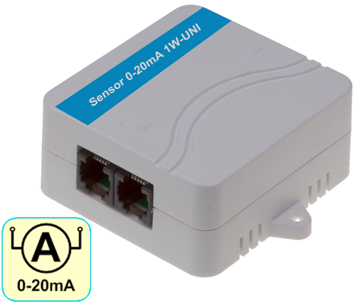
Current sensor converts a 0 to 20 mA current signal from an external probe to the 1-Wire UNI bus.

The 0-20mA input signal is electrically isolated from the output 1Wire-UNI bus.

- Input: 0-20mA (connect a “source” type of probe).
- Electrical isolation: Yes
- Options: Unit conversion, calibration.
- Interface: 1-Wire UNI (2x RJ11 for daisy-chaining)
- Connects to: Poseidon 2250, 4002, Ares 12/14, Poseidon2
- Power supply: Bus-powered (1-Wire UNI) – max. 2 sensors per active port.
- Environment: Indoor use

EN Keywords:
Sensor 4-20mA 1W-UNI, 0 to 20 mA DC (source), 20ma current signal, signal converter,

current transducers, ac current sensor, ac current measurement, current sensing, voltage transducer, dc current sensor, pressure transducers,

