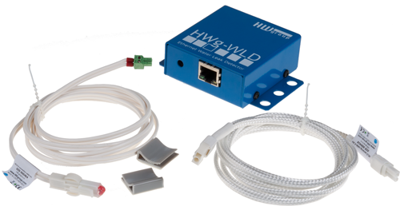
HWg-WLD: 2D Water Leak Detector with Ethernet output
HWg-WLD is 2D area water leakage detection sensor with Ethernet output. Liquid is detected along the entire length of the sensing cable. Detection cable is very easy to extend.

Water leakages are serious issue in modern buildings and data centers with double floors. HWg-WLD detects water leaks or water floods along the entire length of the sensing cable. The sensing cable detects even the smallest volume of water, ethylene glycol, or other conductive liquid. The HWg-WLD can be ordered in two versions depending on the supply of power (power adapter or PoE IEEE 802.3af). Two meters of WLD detection cable is included in the delivery.

2D means whole room surface liquid detection. The sensing cable detects as little as a few drops of the liquid, and can be used to detect condensation. After flooding, the cable can be dried and reused. The WLD sensing cable can be extended anywhere and several times by non-sensing prolong cable. It can significantly reduce cost of the whole installation.

HWg-WLD features a built-in web server and SNMP support. In case of an alarm, the device sends an e-mail or SNMP trap.

Alarms can be also signaled by switching a remote relay over the Ethernet. When a leak is detected, HWg-WLD activates a relay of a remote Poseidon or Damocles unit (Box-2-Box mode).

  - 2D area liquid leak detection, 2 – 85 m sensing cable length
  - Alarm alerts by e-mail, SNMP trap, or by activating a relay output
  - Detects even the smallest volumes of liquids, sensing cable can be dried and reused

Typical applications involve monitoring of coolant piping in air conditioning systems or water detection around pipes in technical areas. The water leak sensing cable can be wrapped around the piping, suspended under the piping, or laid on the bottom of a pipe duct.

- Online demo: http://hwg-wld.hwg.cz
- Ethernet: RJ45 (100BASE-T)
- Web: Built-in web server
- Sensor type: “WLD sensing cable A” Standard types: 2 / 10 / 50 meters
- Supplied sensor: 2 m water sensing cable + 2 m leader cable
- Detection zone: WLD sensing cable (max 85m) can be extended by non-sensing extension cable (max 100m).
- Leak detection: Water / glycol or other conductive liquid
- Power: Power adapter or PoE (IEEE 802.3af), depending on type
- Output: When a water leak is detected, a remote relay is activated over the network (any Poseidon / Damocles)
- M2M communication protocols: SNMP, XML, Modbus/TCP, Box-2-Box
- Response to a sensor being flooded / disconnected: E-mail, SNMP trap, remote relay
- Support for programmers: HWg-SDK
- Supported software
  - HWg-PD Trigger: Alert redirection to SMS, pop-up messages, PC shutdown...
  - HWg-PDMS: Logging of values, graphs, export to MS Excel
  - CapTemp: Visualization on a map, control of outputs, alarm redirection to SMS
  - Third-party SNMP software (HP OpenView, Nagios, Zabbix, The Dude, ..)

Keywords:
HWg-WLD, water leak detector, water flood detector, water leak, SNMP water

IP water detector, water leak detection, pipeline leak detection, liquid detection cable, water flood detector, e-mail water, IEEE 802.3af, cable based water leak detection, spot detector

WLD sensing cable A - 2+2m
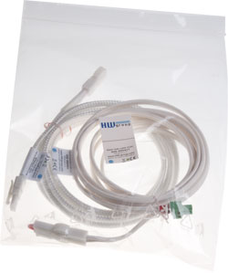
Water leak detection cable pack for ”HWg-WLD” and ”HWg-WLD Relay” products. Includes 2m connection cable and 2m detection cable (total length 4m) and terminator.

- Water Leak Detection cable: 2m (6.5ft)
- Connection leader cable: 2m (6.5ft)
- Extension: Up to 85m (280ft) total length, use “WLD sensing cable A”.
- Compatible with: HWg-WLD, HWg-WLD Relay

WLD sensing cable A – 2+10m
Water leak detection cable pack for ”HWg-WLD” and ”HWg-WLD Relay” products. Includes 2m connection cable and 12m detection cable (total length 12m) and terminator.
.

- Water Leak Detection cable: 10m (33ft)
- Connection leader cable: 2m (6.5ft)
- Extension: Up to 85m (280ft) total length, use “WLD sensing cable A”.
- Compatible with: HWg-WLD, HWg-WLD Relay

